8.38: (a) At maximum compression of the spring, 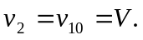 Momentum conservation gives 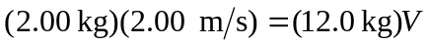

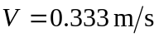
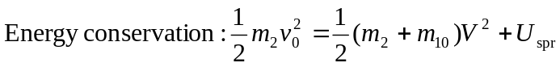
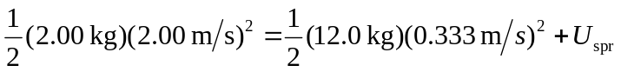
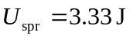

(b) The collision is elastic and Eqs. (8.24) and (8.25) may be used:
